|  |  |  |  |
| --- | --- | --- | --- |
| **Lyng Primary School Knowledge Organiser** | | | |
| **Geography Topic:** | **Bostin’ Black Country**  What human and physical features can I find in the United Kingdom? | Year 2 | Spring |

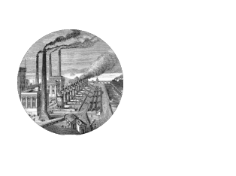

**Background information for parents and teachers**

The Black Country was central to the Industrial revolution. The Industrial Revolution was a time of invention and change that had a significant effect on the way people lived and worked. Until the Industrial Revolution, most people lived in small communities where farming was the main type of work. The Industrial Revolution started in England in the 1760s and soon spread across Europe and to the United States in the west and Japan in the east. In this topic the children will be taught about the countries and capital cities of the UK and the differences between cities, towns and villages and coastal areas.

|  |  |
| --- | --- |
| **What Step On and Goldilocks words will I use?** | |
| **Spelling** | **Definition** |
| Country | A nation with its own government |
| Capital cities | The city that functions as the seat of government of a country |
| Cities | A human settlement of notable size |
| Towns | Larger than a city but smaller than a village |
| Villages | A place where people live, normally the countryside, smaller than a town or city. |
| Rural | Rural areas are found in the countryside surrounded by open land. |
| Coastal | The area where the sea and land meet. |
| Boroughs | A town or district within an area, which has its own council. |
| Aerial view | The view looking down from the air. |
| Land use |  |

|  |
| --- |
| **Geographical skills** |
| * Ask and answer geographical questions. * Identify key features of a location in order to say whether it is a city, town village, coastal or rural area. * Use aerial images and plan perspectives to recognise landmarks and basic physical features. * Devise a simple map and construct basic symbols in a key. |

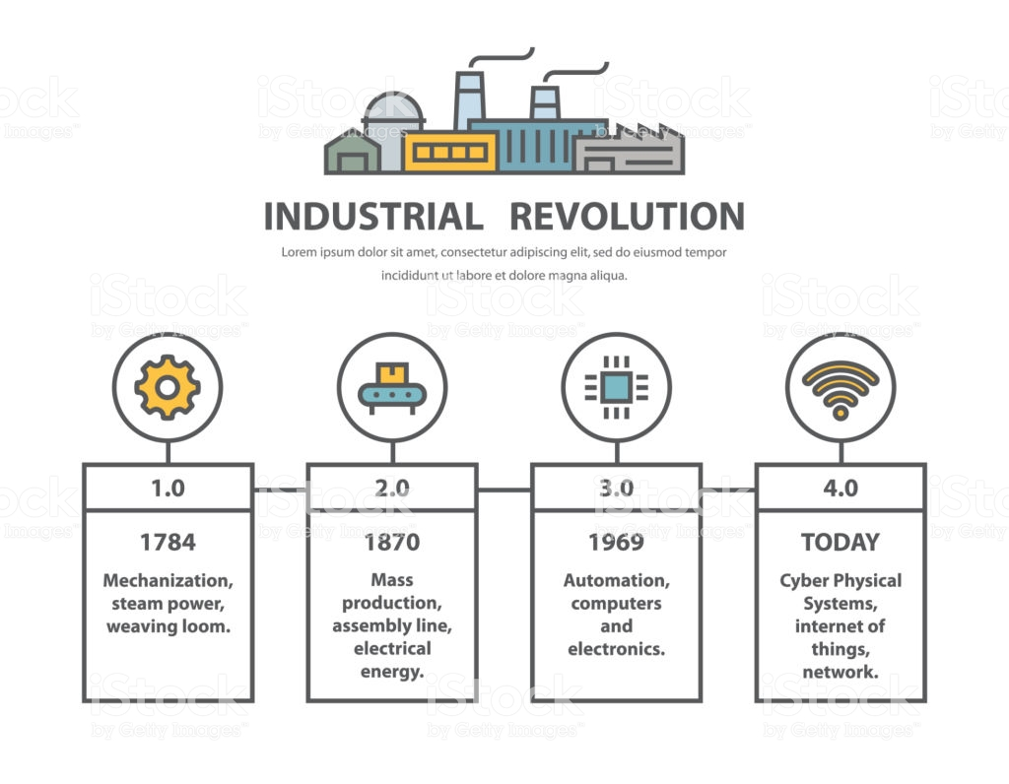



**Significant places**

* Sandwell
* West Bromwich
* Birmingham
* Wolverhampton
* Dudley
* Walsall

**Fieldwork Opportunities**

Walk around the local area to study human and physical features.

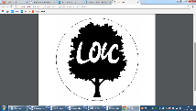

**Map to be studied**

**Key facts and locations**

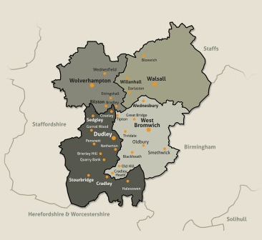

* At the start of the 1800s cities needed more and more people to work in the factories that were being built.
* Birmingham, Liverpool, Leeds and Bradford, Glasgow in Scotland and Cardiff in Wales also grew quickly.
* The movement of people from the countryside to the city meant that lots of houses needed to be built and more food needed to be produced.
* These changes brought great wealth to the country and to the factory owners but also saw many people living in poverty.
* The area became known as The Black Country because the sky was smoky during the day as it was covered in dense black smoke from the many foundries and factories that were built around that time.
* Another theory is that there is a huge amount of coal under the Black Country.
* There are four boroughs that make up the Black Country: Wolverhampton, Dudley, Sandwell and Oldbury.

**Agreed Outcome**

A large map of the local area showing land use.

**Key Questions – sequence of learning**

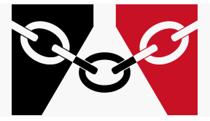

* What are the names of the countries and capital cities in the UK?
* How can you describe different locations in the UK ?
* What can you describe from an aerial view?
* What are the boroughs in the Black Country and what features are in the towns?
* What symbols are there on a map?
* What type of land use is in the local area?

|  |  |  |  |
| --- | --- | --- | --- |
| **Lyng Primary School Knowledge Organiser** | | | |
| **Topic:** | **Bostin’ Black County** | Year 2 | Spring |

|  |  |  |
| --- | --- | --- |
| 6. What does the word industry mean? | **S** | **E** |
| When you play inside |  |  |
| When you dust inside your house |  |  |
| The work involved to make products |  |  |

|  |  |  |
| --- | --- | --- |
| 7. Which city is in the Black Country? | **S** | **E** |
| Wolverhampton |  |  |
| London |  |  |
| Cardiff |  |  |

|  |  |  |
| --- | --- | --- |
| 1. Which town is in the Black Country? | **S** | **E** |
| Oldbury |  |  |
| Northfield |
| Solihull |

|  |  |  |
| --- | --- | --- |
| 1. What was the Black Country famous for? | **S** | **E** |
| Coal mining and factories |  |  |
| Making toys |  |  |
| Making black paint |  |  |

|  |  |  |
| --- | --- | --- |
| 1. What wouldn’t you see on an aerial map of the Black Country? | **S** | **E** |
| sea |  |  |
| buildings |  |  |
| road |  |  |

|  |  |  |
| --- | --- | --- |
| 1. Why is the Black Country called the ‘Black Country’? | **S** | **E** |
| The ground is black |  |  |
| The buildings are black |  |  |
| The smoke made the sky black |  |  |

**Our Bostin’ Black Country**

**Quick Quiz**

|  |  |  |
| --- | --- | --- |
| 1. Where would there be the largest population? | **S** | **E** |
| city |  |  |
| town |  |  |
| village |  |  |

|  |  |  |
| --- | --- | --- |
| 1. Where has the most countryside? | **S** | **E** |
| coastal |  |  |
| rural |
| city |

|  |  |  |
| --- | --- | --- |
| 1. Where would you find the most factories? | **S** | **E** |
| coastal |  |  |
| city |  |  |
| rural |  |  |

|  |  |  |
| --- | --- | --- |
| 1. What does population mean? | **S** | **E** |
| Lots of fizzy pop |  |  |
| A party |  |  |
| The number of people who live in an area |  |  |